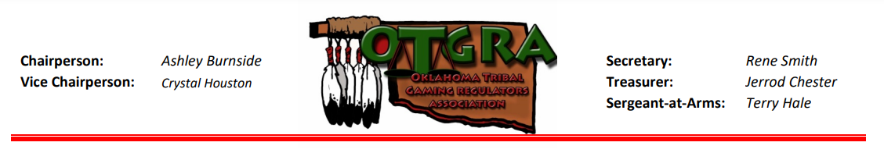
Sponsorship/Donation Request Form

Date:Click or tap here to enter text.

Requesting Organization: Oklahoma Tribal Gaming Regulators Association (OTGRA)
Requesting Organization Event: OTGRA 2023 Fall Conference
Event Dates: October 17-19, 2023
Anticipated # of Participants: 250 – 300

The Oklahoma Tribal Gaming Regulators Association is a non-profit, voluntary association composed of Tribal Gaming Regulatory entities, representing federally recognized tribal governments involved to Oklahoma gaming.

Sponsor Information

Organization Name:Click or tap here to enter text.

Street Address:Click or tap here to enter text.

City:Click or tap here to enter text. State:Click or tap here to enter text. Zip: Click or tap here to enter text.

ContactClick or tap here to enter text. Contact Title:Click or tap here to enter text.

Contact Email:Click or tap here to enter text. Contact Phone:Click or tap here to enter text.

Event Sponsorship (check item(s) and see ”Sponsorship Opportunities” document for all details)

☐Platinum Level - $5,000 ☐Gold Level - $3,000 ☐Silver Level - $1,500
☐Bronze Level - $1,000 ☐Photo Booth - $1,000 ☐Professional Head Shot - $1,000
☐Breakfast and/or Breaks - $800 ☐Branded Giveaways in “swag bags” (250 +/- items needed; please describe item(s), including quantity:Click or tap here to enter text.

☐Jess Green Scholarship - Gold Level-$500 ☐Jess Green Scholarship – Silver Level-$250

Mail/Email form with payment to: Jerrod Chester/OTGRA
c/o Miami Tribe Gaming Commission
P.O. Box 1326
Miami, OK 74355

Build a Sponsorship … Customized it to fit your marketing goals and budget!

Questions? Please contact Vicki Kruse @ victoriakruse210@gmail.com

