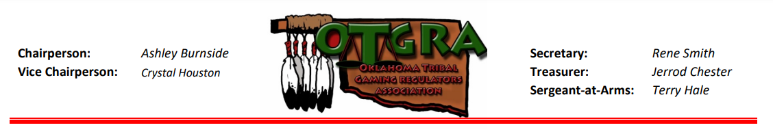
Speaker Proposal
Please provide your proposal by August 15, 2023, to be considered.

The Oklahoma Tribal Gaming Regulators Association (OTGRA) Fall 2023 Conference will be held at the Grand Casino Resort Hotel in Shawnee, OK. The conference dates are October 17-19, 2023.
As we continually work to expand the trainings offered to provide content beneficial to our attendees, we are looking for presentations on the following topics as they relate to regulation:
- Audits and Investigations
- Commission Topics
- Compliance, Surveillance and Technology
- Licensing and Investigations
The plan is to offer four general sessions and 16 breakout sessions, each scheduled for approximately 1 hour.
Specific topic requests from the Spring 2023 Conference attendees included:
- Human Relations, Emotional Intelligence and Management Styles
- Self-Regulation
- Barred Patron Funds and Barred Patron List
- Sports Betting
- Team Building
- Human Trafficking
- Auditing Table Games
- Counterfeit Money
- State Compact Regulations
- Vendor Licensing Regulations
- MICS/TICS/SICS Assessments
If you would like to be considered as a presenter for a breakout or general session, please complete the attached form and send to our Event Coordinator, Vicki Kruse at victoriakruse210@gmail.com . Note that you may submit more than one proposal, each on a separate form, please.
Speakers are provided a complimentary conference registration and banquet ticket. Travel and hotel accommodations will be at your own expense.
Thank you for your interest in sharing your knowledge by speaking at our OTGRA conference. We look forward to working with you.

Speaker Proposal
Please submit your proposal to victoriakruse210@gmail.com August 15th. We will make attendees aware of the awesome and informative topics on our website!
Please complete and submit a separate form for each topic proposal.

Name:Click or tap here to enter text.

Title:Click or tap here to enter text.

Organization:Click or tap here to enter text.

Email:Click or tap here to enter text.

Phone including Area Code:Click or tap here to enter text.

Title and Overview of Presentation:
Click or tap here to enter text.

Target Audience (please check one) :

Audits and Investigations ☐
General Commission Topics ☐
Compliance, Surveillance and Technology ☐
Licensing and Investigations ☐
Other (be specific) Click or tap here to enter text.

Audio Visual or Special Set-up Required:
Click or tap here to enter text.

